Front-End UI/UX Mini Project   
   
 Course: UI/UX Design Fundamentals

Project Title

My Favourtie City Blog

**Submitted by:**

* Aditya Mishra: (2462307) [-aditya.mishra@btech.christuniversity.in](mailto:-aditya.mishra@btech.christuniversity.in)
* Pallavi Gupta (2462346) [pallavi.gupta@btech.christuniveristy.in](mailto:pallavi.gupta@btech.christuniveristy.in)
* Vidhika Singh (2462371)

[Vidhika.singh@btech.christuniversity.in](mailto:Vidhika.singh@btech.christuniversity.in)

**Instructor Name:** Ms Nagaveena**Date of Submission**:13/08/2025 

**Institution:** Christ University ,Bangalore

**1.Abstract:**

The City Blog is a dynamic and visually engaging web project that showcases a city I love through curated text, images, and interactive links. Built using semantic HTML5 elements, the blog structure ensures clarity and accessibility. CSS styles enhance the layout, while **Bootstrap** provides responsive design and prebuilt components for a polished, mobile-friendly experience. **JavaScript** adds interactivity—such as image sliders and form validation—while **jQuery** simplifies DOM manipulation and event handling, making the site more responsive and user-friendly. Together, these technologies create a cohesive and immersive digital storytelling platform.

**2.Objectives:**

* Use semantic HTML tags like header, footer article and section for clear structure
* Include images, headings, and paragraphs to make the content visually engaging
* Add hyperlinks to relevant resources or attractions in the city
* Organize content for easy readability and smooth navigation using **Bootstrap’s grid system and components**
* Enhance interactivity with **JavaScript** (e.g., image sliders, form validation) and **jQuery** for simplified DOM manipulation
* Demonstrate foundational and intermediate web development skills through layout, styling, and dynamic behavior

**3. Scope of the project:**

* Use semantic HTML tags like , , , and for clear structure
* Include images, headings, and paragraphs to make the content visually engaging
* Add hyperlinks to relevant resources or attractions in the city
* Organize content for easy readability and smooth navigation using **Bootstrap’s grid system and components**
* Enhance interactivity with **JavaScript** (e.g., image sliders, form validation) and **jQuery** for simplified DOM manipulation
* Demonstrate foundational and intermediate web development skills through layout, styling, and dynamic behavior

**4. HTML structure Overview:**

* Html : Root element containing the entire webpage
* Head : Includes metadata, page title, and links to stylesheets
* Body : Main content area of the blog
* Header : Title of the blog and city name
* Nav : Navigation menu with anchor links to different sections
* Section : Major content blocks like "About the City", "Top Attractions", "Local Cuisine", etc.
* Article : Individual write-ups or highlights within each section
* Img :Images representing landmarks, food, or cultural elements
* A : Hyperlinks to external resources or internal na
* vigation
* Footer : Closing notes, contact info, or credits

**5. Tools & Technologies Used** :

|  |  |
| --- | --- |
| **Tool/Technology** | **Purpose** |
| **HTML5** | Markup and content structure |
| **CSS3** | Styling and layout management |
| **VS Code** | Code editor |
| **Chrome DevTools** | Testing and debugging |
| **Bootstrap** | Implement responsive design, grid layout, and prebuilt UI components like navbar, cards, and modals |
| **jQuery** | Simplify DOM manipulation, event handling, and AJAX calls if needed |

**6. HTML Structure Overview**

* Used semantic tags: <header>, <nav>, <main>, <section>, <footer>
* Structured into reusable sections: About, Projects, Contact

**7. CSS Styling Strategy:**

* Section spacing: padding and margin to separate content.
* Headings: Larger font-size and distinct color for each section title.
* Box styling: Use border, box-shadow, or background-color to highlight articles or tips.
* Responsive sizing: width: 100% or max-width: 600px to fit nicely.
* Rounded corners: border-radius for a softer look.
* Shadow: box-shadow to make images stand out.
* Bullet styling: Customize list-style-type (e.g., circle, square).
* Spacing: Add margin-bottom between list items.

**8.Bootstrap styling Strategy:**

* Use the grid system (container, row, col) to organize your layout cleanly.
* Apply utility classes like m-3, p-2, text-center for quick spacing and alignment.
* Use prebuilt components such as navbar, card, and carousel to save time and ensure consistency.
* Make images responsive with img-fluid so they scale properly on all devices.
* Customize styles by adding your own CSS file after Bootstrap’s link to override default styles.

**9.JavaScript & jQuery Styling Strategy**

1. **Use clear variable and function names** – e.g., showCityInfo(), userInput, not vague names like x or temp.
2. **Wrap jQuery code in $(document).ready()** – ensures scripts run only after the page is fully loaded.
3. **Organize code into reusable functions** – keeps logic clean and easy to maintain.
4. **Chain jQuery methods when possible** – e.g., $('#box').addClass('active').fadeIn(); for concise code.
5. **Add comments and consistent indentation** – improves readability and helps with debugging later.

10. **challenges and solutions:**

| Challenge | Solution |
| --- | --- |
| Structuring content clearly | Used semantic tags like and for organization |
| Making the page visually appealing | Applied CSS for layout, colors, and typography |
| Image alignment and sizing | Used max-width, margin, and display properties in CSS |

**11. Outcome:**

* Structured Content: Clear sections like About, Attractions, Food, and Travel Tips make it easy to navigate.
* Visual Appeal: Images and styling bring the city to life.
* User-Friendly Navigation: Visitors can jump to sections using the nav bar.
* Personal Touch: Your voice and preferences shine through in descriptions and choices.
* Responsive Layout *(if styled well)*: It looks good on both desktop and mobile.

**12.Future Enhancements:**

* **Interactive Map Integration**  
  Embed a live map using APIs like **Google Maps JavaScript API** to show key attractions, restaurants, or travel routes within the city.
* **Search and Filter Functionality**  
  Use **JavaScript or jQuery** to allow users to search for specific attractions or filter content by category (e.g., food, culture, travel tips).
* **User Feedback Form with Validation**  
  Add a contact or feedback form with **JavaScript-based validation** and optional **AJAX submission** for smoother user experience.
* **Theme Toggle (Light/Dark Mode)**  
  Implement a **JavaScript toggle switch** to let users switch between light and dark themes, enhancing accessibility and personalization.
* **Image Carousel and Modal Popups**  
  Use **Bootstrap’s carousel** for showcasing city images and **modals** for displaying detailed content without navigating away.
* **Blog Post Expansion with Local Events**  
  Add a section for upcoming city events using **JSON data** or **API integration**, and dynamically update it using JavaScript.

**13. Sample Code:**

<!DOCTYPE html>

<html lang="en">

<head>

<meta charset="UTF-8">

<meta name="viewport" content="width=device-width, initial-scale=1.0">

<meta name="description" content="A modern responsive blog layout with dark mode, filters, animations, and social sharing.">

<title>Enhanced Blog Layout</title>

<style>

body {

font-family: 'Poppins', sans-serif;

margin: 0;

padding: 0;

background: #f4f4f4;

color: #333;

transition: background 0.3s, color 0.3s;

}

header {

background: #6200ea;

color: white;

padding: 1rem;

text-align: center;

}

.dark-mode {

background: #1e1e1e;

color: #e0e0e0;

}

.container {

max-width: 1200px;

margin: auto;

padding: 1rem;

}

.search-bar {

display: flex;

justify-content: center;

margin-bottom: 1rem;

}

.search-bar input {

padding: 0.5rem;

width: 60%;

border: 1px solid #ccc;

border-radius: 4px;

}

.categories {

text-align: center;

margin-bottom: 1rem;

}

.categories button {

margin: 0.3rem;

padding: 0.5rem 1rem;

border: none;

border-radius: 20px;

cursor: pointer;

transition: background 0.3s;

color: white;

}

.categories .tech { background: #4caf50; }

.categories .life { background: #ffc107; }

.categories .travel { background: #2196f3; }

.categories button:hover { opacity: 0.8; }

.grid {

display: grid;

grid-template-columns: repeat(auto-fit, minmax(280px, 1fr));

gap: 1rem;

}

.card {

background: white;

border-radius: 10px;

overflow: hidden;

box-shadow: 0 2px 6px rgba(0,0,0,0.2);

transition: transform 0.3s;

opacity: 0;

transform: translateY(20px);

animation: fadeIn 0.8s forwards;

}

@keyframes fadeIn {

to { opacity: 1; transform: translateY(0); }

}

.card img {

width: 100%;

height: 180px;

object-fit: cover;

}

.card-content {

padding: 1rem;

}

.card-content h3 {

margin: 0.5rem 0;

}

.meta {

font-size: 0.85rem;

color: gray;

margin-bottom: 0.5rem;

}

.read-more {

display: inline-block;

margin-top: 0.5rem;

color: #6200ea;

text-decoration: none;

font-weight: bold;

cursor: pointer;

}

.read-more:hover {

text-decoration: underline;

}

.social-share {

margin-top: 0.5rem;

}

.social-share a {

margin-right: 0.5rem;

text-decoration: none;

font-size: 0.9rem;

color: #6200ea;

}

.toggle-dark {

position: fixed;

top: 10px;

right: 10px;

background: #333;

color: white;

border: none;

border-radius: 20px;

padding: 0.5rem 1rem;

cursor: pointer;

}

</style>

</head>

<body>

<header>

<h1>My Awesome Blog</h1>

</header>

<button class="toggle-dark">🌙 Dark Mode</button>

<div class="container">

<div class="search-bar">

<input type="text" id="search" placeholder="Search posts...">

</div>

<div class="categories">

<button class="tech" onclick="filterCategory('Technology')">Technology</button>

<button class="life" onclick="filterCategory('Lifestyle')">Lifestyle</button>

<button class="travel" onclick="filterCategory('Travel')">Travel</button>

<button onclick="filterCategory('All')">All</button>

</div>

<div class="grid" id="blogGrid">

<!-- Technology Card -->

<div class="card" data-category="Technology">

<img src="https://images.unsplash.com/photo-1518770660439-4636190af475?auto=format&fit=crop&w=400&h=200&q=80" alt="Technology">

<div class="card-content">

<h3>Latest Tech Trends</h3>

<p class="meta">By Admin | Sep 24, 2025</p>

<p>Discover the latest innovations in AI, robotics, and more...</p>

<a href="post-tech.html" class="read-more">Read More</a>

<div class="social-share">

<a href="#">Twitter</a>

<a href="#">Facebook</a>

<a href="#">LinkedIn</a>

</div>

</div>

</div>

<!-- Lifestyle Card -->

<div class="card" data-category="Lifestyle">

<img src="https://images.unsplash.com/photo-1505751172876-fa1923c5c528?auto=format&fit=crop&w=400&h=200&q=80" alt="Lifestyle">

<div class="card-content">

<h3>Healthy Living Tips</h3>

<p class="meta">By Jane | Sep 20, 2025</p>

<p>Improve your lifestyle with simple daily habits...</p>

<a href="post-lifestyle.html" class="read-more">Read More</a>

<div class="social-share">

<a href="#">Twitter</a>

<a href="#">Facebook</a>

<a href="#">LinkedIn</a>

</div>

</div>

</div>

<!-- Travel Card -->

<div class="card" data-category="Travel">

<img src="https://images.unsplash.com/photo-1507525428034-b723cf961d3e?auto=format&fit=crop&w=400&h=200&q=80" alt="Travel">

<div class="card-content">

<h3>Top 10 Travel Destinations</h3>

<p class="meta">By Alex | Sep 15, 2025</p>

<p>Explore the most beautiful places around the world...</p>

<a href="post-travel.html" class="read-more">Read More</a>

<div class="social-share">

<a href="#">Twitter</a>

<a href="#">Facebook</a>

<a href="#">LinkedIn</a>

</div>

</div>

</div>

</div>

</div>

<script>

// Dark Mode Toggle with persistence

const toggleBtn = document.querySelector('.toggle-dark');

const body = document.body;

if(localStorage.getItem('darkMode') === 'enabled'){

body.classList.add('dark-mode');

}

toggleBtn.addEventListener('click', () => {

body.classList.toggle('dark-mode');

if(body.classList.contains('dark-mode')){

localStorage.setItem('darkMode','enabled');

} else {

localStorage.setItem('darkMode','disabled');

}

});

// Search Functionality

document.getElementById('search').addEventListener('keyup', function(){

const query = this.value.toLowerCase();

document.querySelectorAll('.card').forEach(card => {

const text = card.innerText.toLowerCase();

card.style.display = text.includes(query) ? 'block' : 'none';

});

});

// Category Filter

function filterCategory(cat){

document.querySelectorAll('.card').forEach(card => {

if(cat === 'All' || card.dataset.category === cat){

card.style.display = 'block';

} else {

card.style.display = 'none';

}

});

}

</script>

</body>

</html>

**14. Screenshots of Final Output :**

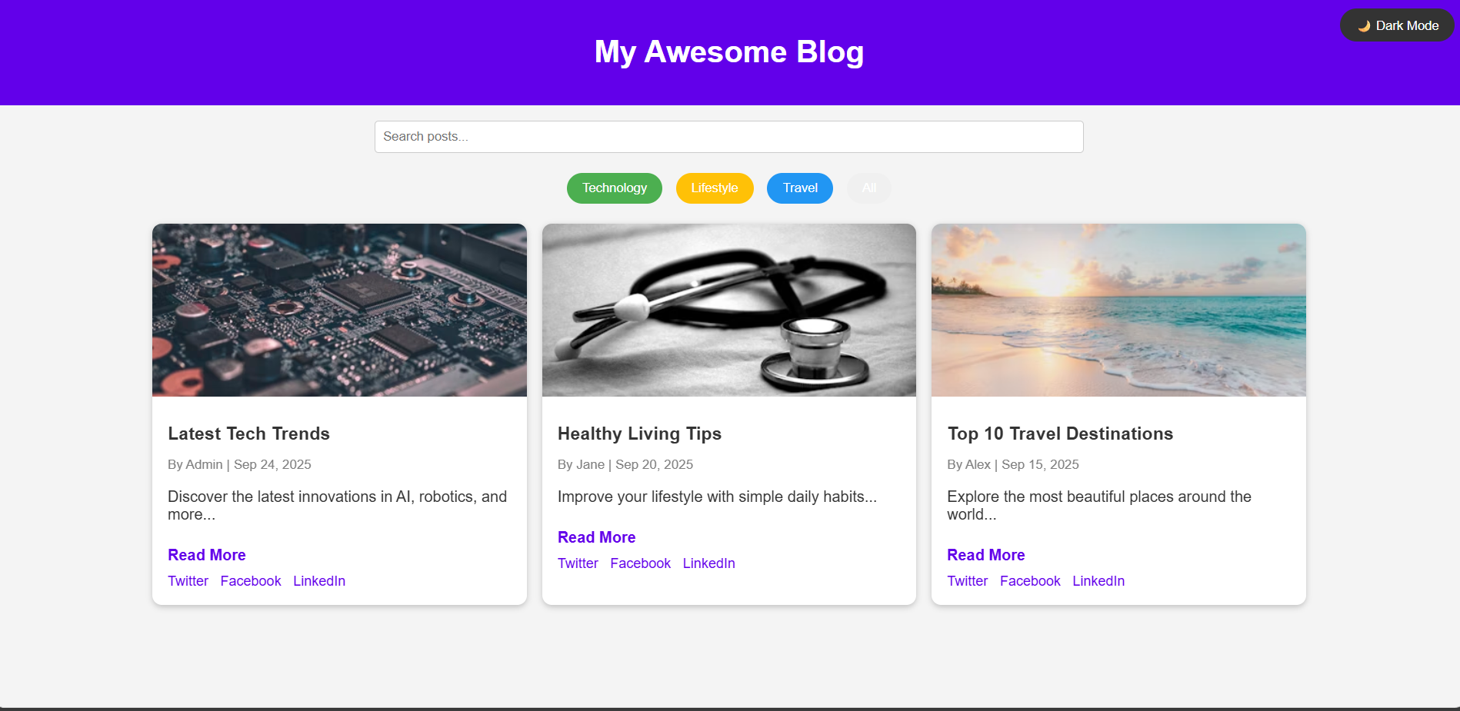

**15. Conclusion:**

Creating this blog about my favourite city was a rewarding experience that allowed me to strengthen my understanding of HTML structure, apply CSS styling, and organize content in a clear, engaging format. By integrating Bootstrap, I achieved a responsive layout, and with JavaScript and jQuery, I added interactive elements that enriched the user experience. This project blended creativity with technical skill, helping me appreciate the power of front-end development. I look forward to expanding the blog with new features—such as dynamic content, user feedback forms, and interactive maps—as I continue learning and refining my web development abilities

**16.Reference:**

L&T LMS : https://learn.lntedutech.com/Landing/MyCourse